StoreMinder Inventory Management System
Web Design Final Exam Project Documentation

Student Name: Adeline Uwitonze

Registration Number: 26753

Course: Web Design

Date: July 29, 2025
Table of Contents
1 Project Introduction 3
1.1 Overview 3
2 Problem Statement 3
3 System Requirements 4
3.1 Software Requirements 4
3.2 Hardware Requirements 4
4 System Design 5
4.1 User Flow Diagram 5
4.2 Page Structure 5
4.3 Navigation System 6
5 Implementation 6
5.1 HTML Structure 6
5.2 CSS Styling & Responsiveness 6
5.3 JavaScript Interactivity 6
5.4 JavaScript Form Validation 7
5.5 PHP Form Handling 7
5.6 Database Integration 7
6 Database Design 7
6.1 Database Name 7
6.2 ER Diagram Structure 8
6.3 Tables and Relationships 8
6.3.1 companies 8
6.3.2 users 9
6.3.3 products 9
6.3.4 transactions 9
6.3.5 sales 9
6.4 Key Relationships 10
7 Testing 10
7.1 Testing Methodology 10
7.2 Bugs Found and Fixed 11
8 Challenges Faced 12
9 Conclusion 12
9.1 Learning Outcomes 12
9.2 Future Improvements 13
9.3 Project Success Metrics 13
10 Screenshots 13

Project Introduction

Overview
Title: StoreMinder - Modern Inventory Management System
Case Study: StoreMinder is designed for small to medium-sized retail businesses, hardware stores, and quincaillerie shops in Rwanda. It empowers business owners and store managers to efficiently manage inventory, track sales, generate reports, and handle customer transactions.
Purpose: StoreMinder addresses the challenges of manual inventory management by providing:
- Automated inventory tracking and stock management
- Real-time sales recording and transaction management
- Comprehensive business reports and analytics
- Multi-user access with role-based permissions
- Data security and backup for business continuity Technologies Used:
- Frontend: HTML5, CSS3, JavaScript (ES6+)
- Backend: PHP 8.0+
- Database: MySQL 8.0+
- Server: XAMPP (Apache + MySQL + PHP)
- Additional Libraries:
  - Chart.js for data visualization
  - FPDF for PDF report generation
  - PHPMailer for email functionality
  - Simple Icons for UI elements

Problem Statement
Manual inventory management in small businesses is:
- Time-consuming and error-prone
- Difficult for accurate stock tracking

Challenging for generating business insights
Vulnerable to data loss
- Limited in scalability
Target Users:
- Business Owners: Need business performance and financial reports
- Store Managers: Require daily inventory and sales tracking
- Sales Staff: Need to record transactions and check product availability
- Administrators: Manage user accounts and system settings
Key Features:
- Real-time inventory tracking with low-stock alerts
- Sales recording with multiple payment methods
- Customer transaction management
- Comprehensive reporting and analytics
- Multi-user access with role-based security
- Responsive design for mobile and desktop

System Requirements

Software Requirements
- Web Browser: Chrome 90+, Firefox 88+, Safari 14+, Edge 90+
- Code Editor: Visual Studio Code (recommended)
- Server Environment: XAMPP 8.0+ (Apache + MySQL + PHP)
- Database: MySQL 8.0+
- PHP Version: 8.0 or higher

Hardware Requirements
- Minimum: 4GB RAM, 2GB free disk space
- Recommended: 8GB RAM, 5GB free disk space
- Network: Internet connection for external libraries and email functionality

System Design

User Flow Diagram
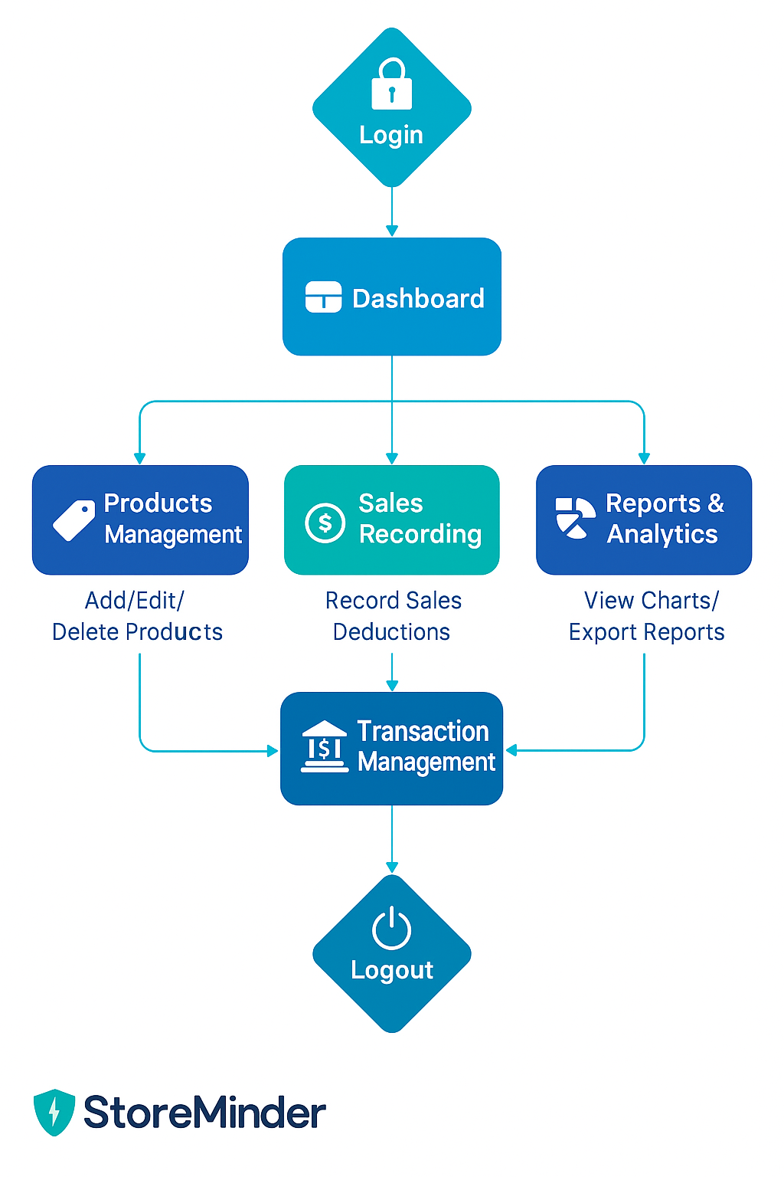

Page Structure
- index.php - Landing page with login/signup modals
- dashboard.php - Business overview dashboard
- products.php - Product inventory management
- sales.php - Sales recording and deduction tracking
- transactions.php - Customer transaction management
- transaction_{r}eceipt.php−Receiptgenerationandsharingreports.php−Businessanalyticsandrep
7.7. users.php - User management (admin only)
- login.php - User authentication
- register.php - User registration

Navigation System
- Fixed header with responsive navigation menu
- Role-based menu items
- Breadcrumb navigation
- Mobile-responsive hamburger menu

Implementation

HTML Structure
- Semantic tags: <header>, <nav>, <main>, <footer>, <section>, <article>
- Clean, well-indented code
- Accessible form labels and ARIA attributes
Responsive meta tags and viewport settings
Modal dialogs, data tables, form validation attributes, responsive grid layouts

CSS Styling & Responsiveness
- CSS Variables for consistent theming
- Modern gradient backgrounds and glassmorphism effects
- Mobile-first responsive design
- Professional color scheme and typography
- CSS Grid, Flexbox, media queries, smooth transitions

JavaScript Interactivity
- Theme toggle (dark/light mode)
- Modal open/close functionality
- Form auto-fill and validation
- Smooth scrolling and animations
- Dynamic content loading

JavaScript Form Validation
- Real-time email format validation
- Required field checking
- Password strength validation
- Form submission prevention on errors
- User-friendly error messages

PHP Form Handling
- Secure POST method handling
- Comprehensive error handling
- Session management and security
- File upload handling for receipts
- Email functionality integration

Database Integration
- Proper database relationships and foreign keys
- Optimized queries with prepared statements
- Transaction support for data integrity
- Backup and recovery procedures

Database Design

Database Name
quincaillerie_{m}anager

ER Diagram Structure
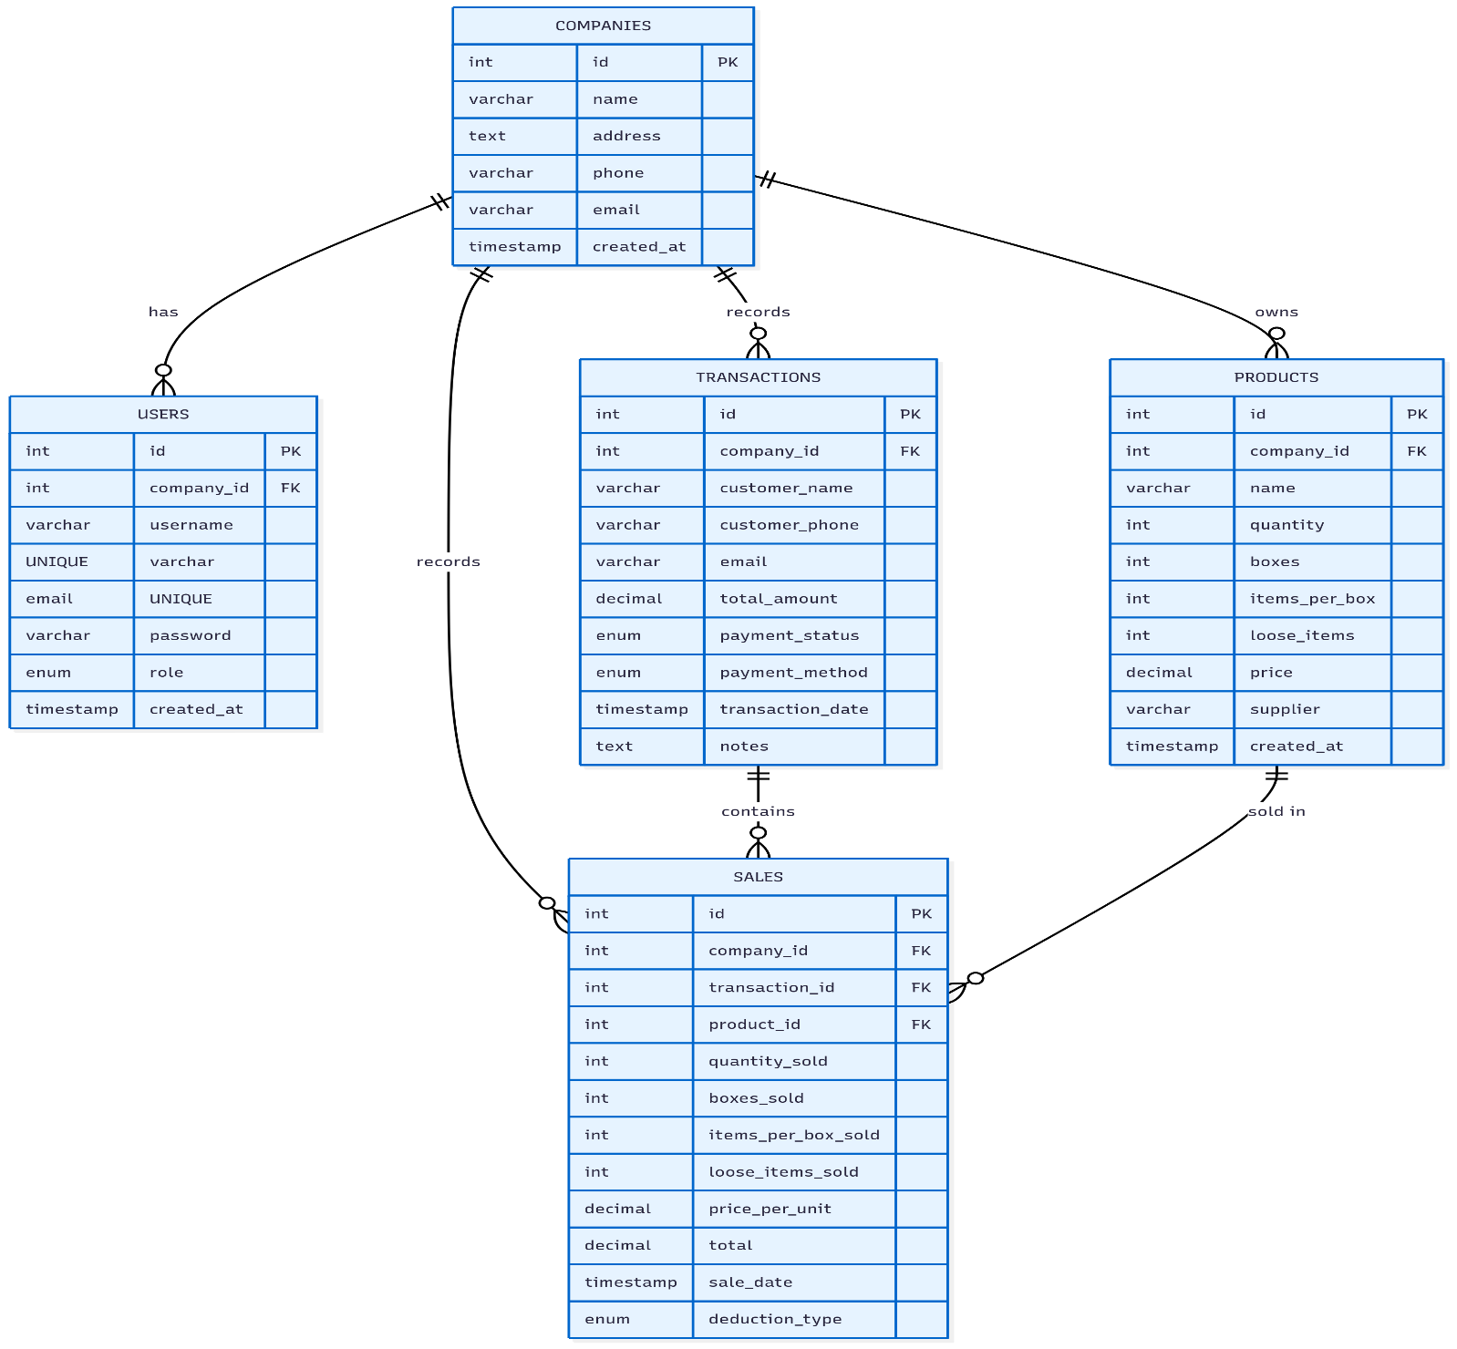

Tables and Relationships

companies
- id (INT, Primary Key, Auto Increment)
- name (VARCHAR(255), NOT NULL)
- address (TEXT)
- phone (VARCHAR(20))
- email (VARCHAR(100))
- created_{a}t(TIMESTAMP,DEFAULTCURRENT_{T}IMESTAMP)

users
- id (INT, Primary Key, Auto Increment)
- company_{i}d(INT,ForeignKey→ companies.id)
- username (VARCHAR(50), UNIQUE, NOT NULL)
- email (VARCHAR(100), UNIQUE, NOT NULL)
password (VARCHAR(255), NOT NULL) role (ENUM(’admin’, ’user’), DEFAULT ’user’)
- created_{a}t(TIMESTAMP,DEFAULTCURRENT_{T}IMESTAMP)

products
- id (INT, Primary Key, Auto Increment)
- company_{i}d(INT,ForeignKey→ companies.id)
- name (VARCHAR(255), NOT NULL)
- quantity (INT, DEFAULT 0)
- boxes (INT, DEFAULT 0)
- items_{p}er_{b}ox(INT,DEFAULT0)

transactions
•• id (INT, Primary Key, Auto Increment)
- company_{i}d(INT,ForeignKey→ companies.id)
- customer_{n}ame(V ARCHAR(255),NOTNULL)

sales
•• id (INT, Primary Key, Auto Increment)
- company_{i}d(INT,ForeignKey→ companies.id)
- transaction_{i}d(INT,ForeignKey→ transactions.id)
- product_{i}d(INT,ForeignKey→ products.id)
- quantity_{s}old(INT,NOTNULL)

Key Relationships
•• Multi-tenant architecture with company isolation
- Referential integrity with CASCADE delete
- Optimized indexes for performance

Testing

Testing Methodology
- Manual Testing:
  - User registration and login
  - Product CRUD operations
  - Sales recording and transaction management
  - Report generation and export
  - Role-based access control
- Form Validation Testing:
  - Client-side (JavaScript)
  - Server-side (PHP)
  - Database constraints • Error handling and feedback
- Cross-browser Testing:
  - Chrome, Firefox, Safari, Edge compatibility
  - Mobile responsiveness • Different screen sizes
- Security Testing:
  - SQL injection prevention
  - XSS protection
  - Session security
  - Input sanitization

Bugs Found and Fixed
- Foreign Key Constraint Error: Fixed missing companies table relationships
- Missing Database Column: Added loose_{i}temstoproductstableNavigation Overlap:Fixedth
- Database Connection Issues: Implemented proper error handling

Challenges Faced
- Multi-tenant Architecture:
  - Challenge: Implementing company isolation
  - Solution: Used foreign key relationships and company-based filtering
- Database Schema Evolution:
  - Challenge: Adding columns without data loss
  - Solution: Used ALTER TABLE with default values
- Responsive Design:
  - Challenge: Consistent UI across screen sizes
  - Solution: Mobile-first CSS with Grid and Flexbox
- Security Implementation:
  - Challenge: Preventing SQL injection
  - Solution: Used prepared statements and sanitization
- User Experience:
  - Challenge: Intuitive interface for non-technical users
  - Solution: Modern UI patterns and clear navigation

Conclusion

Learning Outcomes
- Full-Stack Development: Expertise in HTML, CSS, JavaScript, PHP, MySQL
- Database Design: Normalization and relationship management
- Security Best Practices: Secure coding and data protection
- User Experience Design: Intuitive and responsive interfaces
- Project Management: Planning, implementation, and testing

Future Improvements
- Advanced analytics with machine learning
- Native mobile applications
- RESTful API development
- Cloud infrastructure migration
- Sophisticated reporting tools
- Barcode scanning and automated stock alerts

Project Success Metrics
- Complete inventory management functionality
- Multi-user role-based access control
- Responsive design for all devices
- Comprehensive reporting system
- Secure data handling and storage
- Professional UI/UX design

Screenshots
- Landing Page (index.php): Hero section, login/signup modals, mobile view
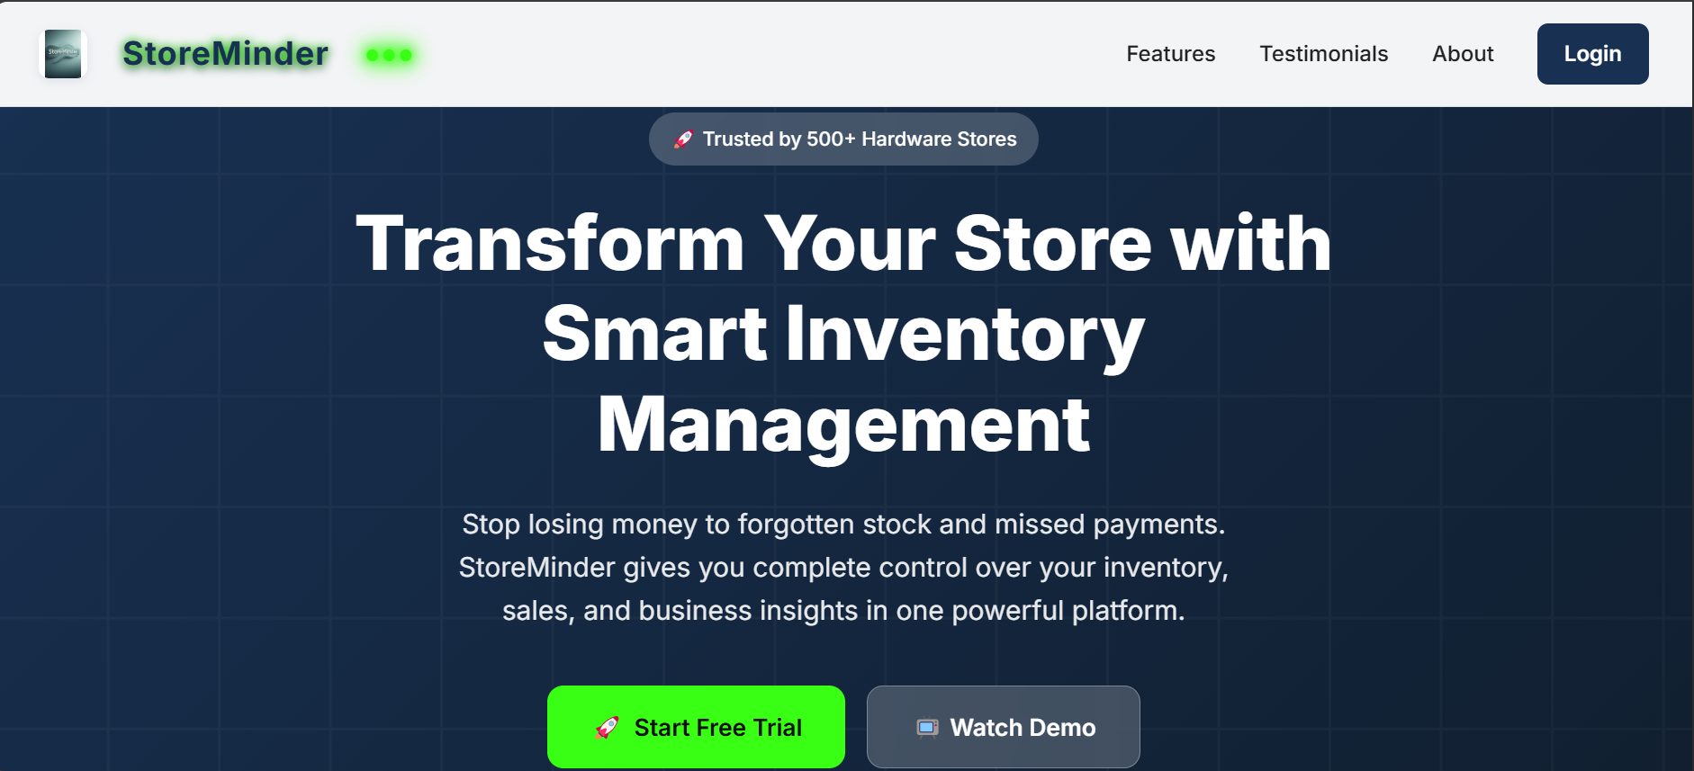
- Dashboard (dashboard.php): Business overview, quick actions, low stock alerts
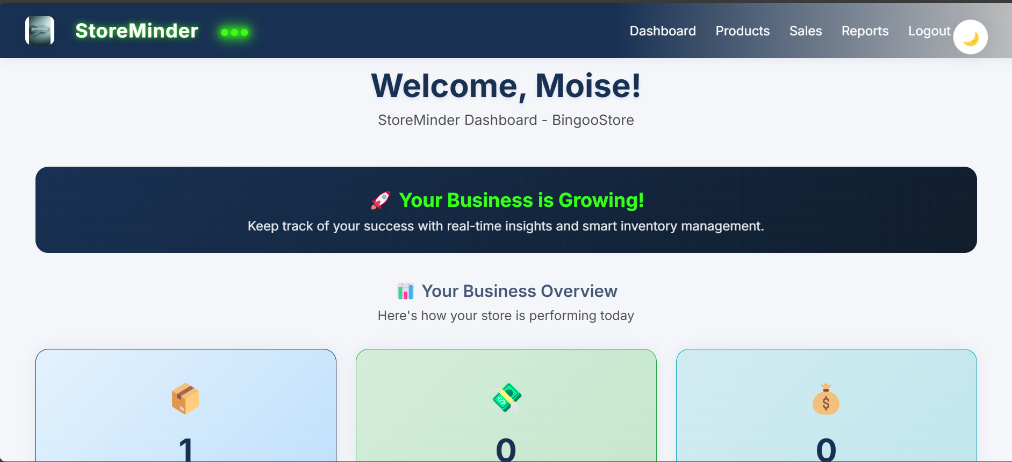
- Products Management (products.php): Add product form, inventory table, edit/delete
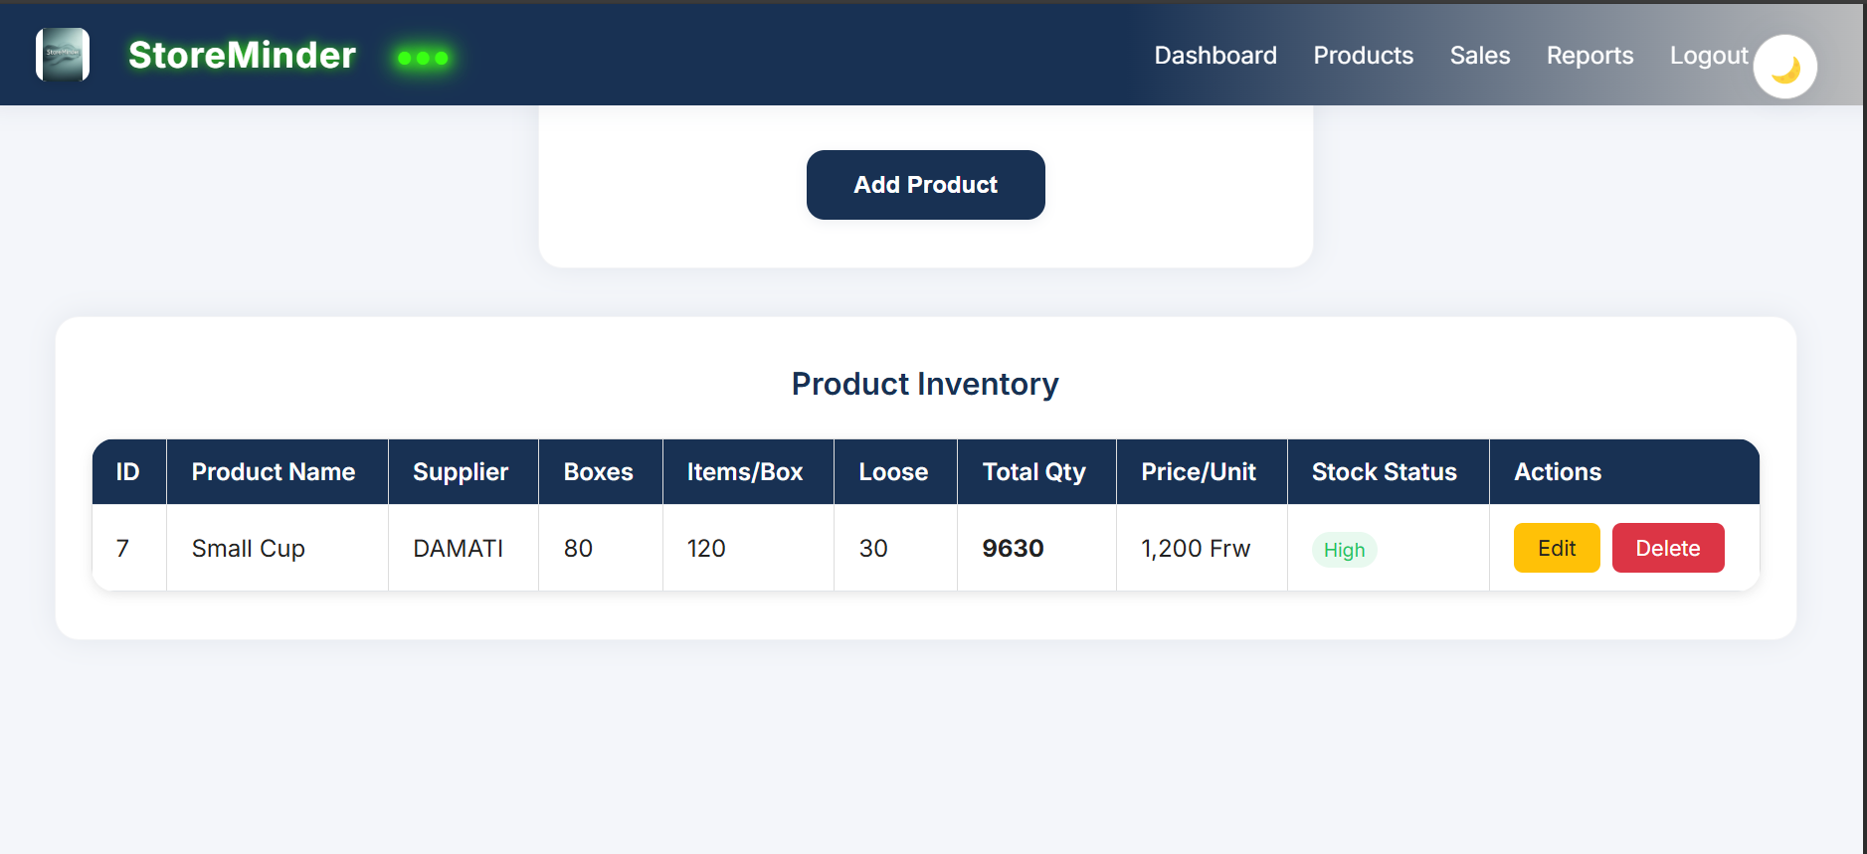
- Sales Recording (sales.php): Sales form, history table, transaction details
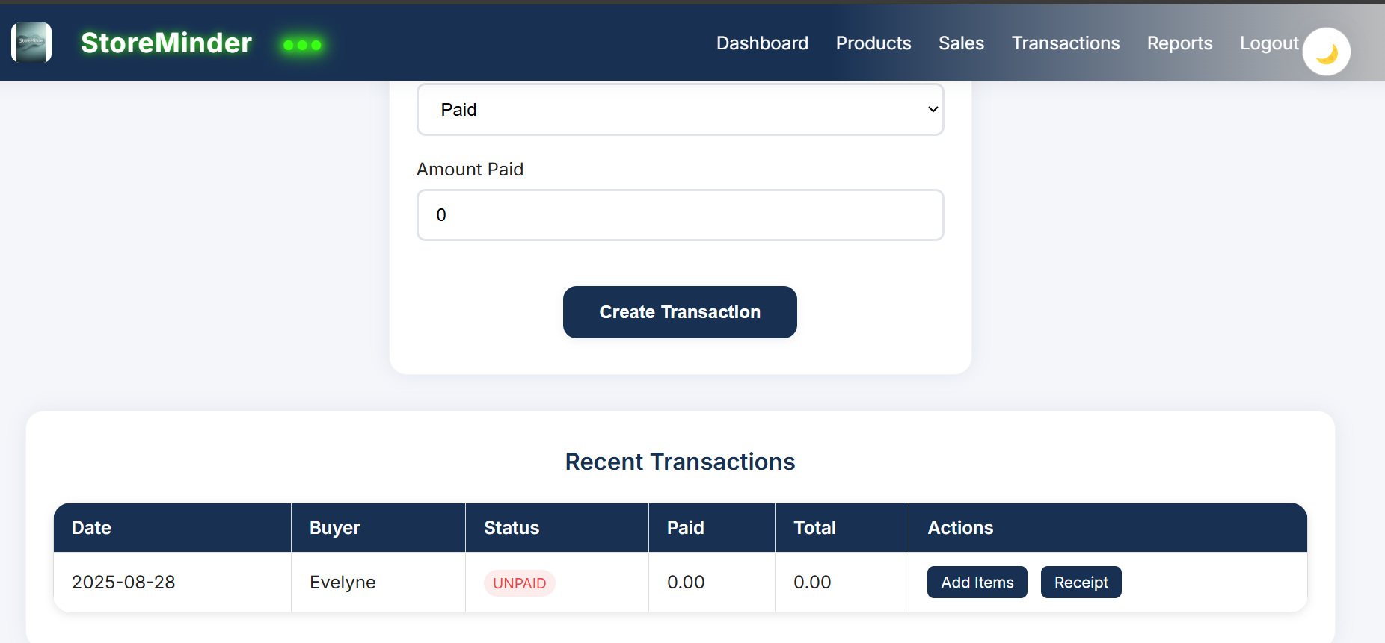
- Reports (reports.php): Charts, export functionality, filter options
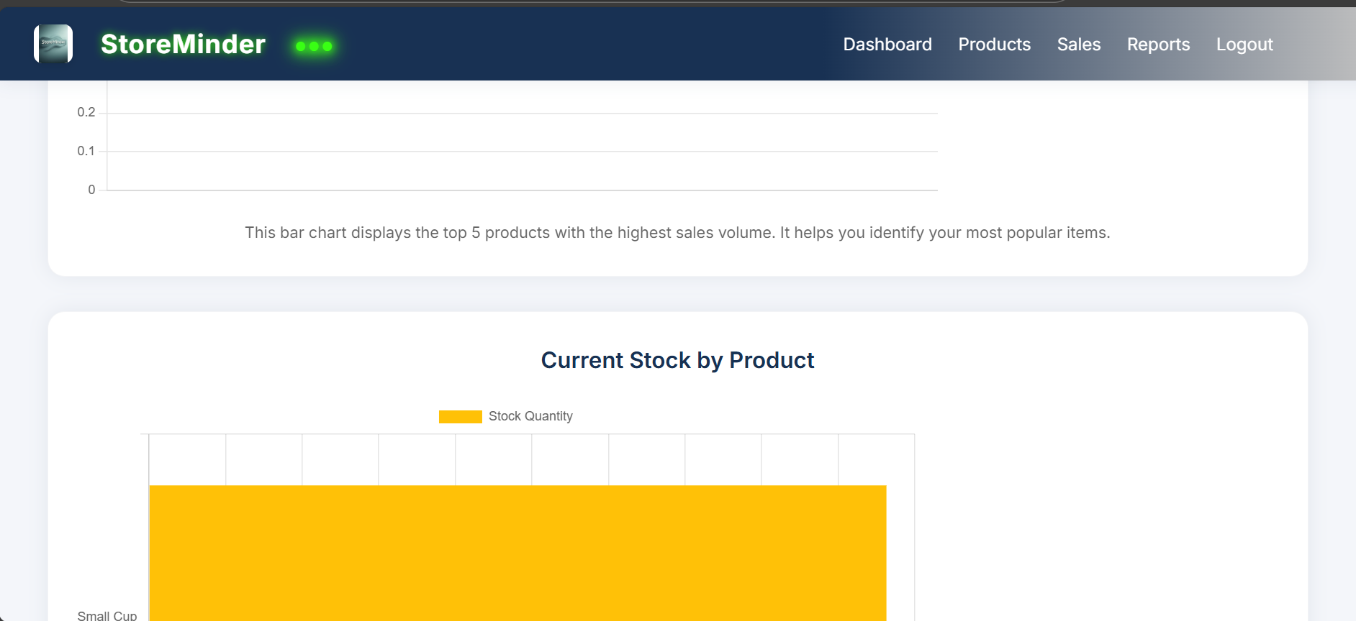
- Database Views: phpMyAdmin table structure, sample data, foreign keys
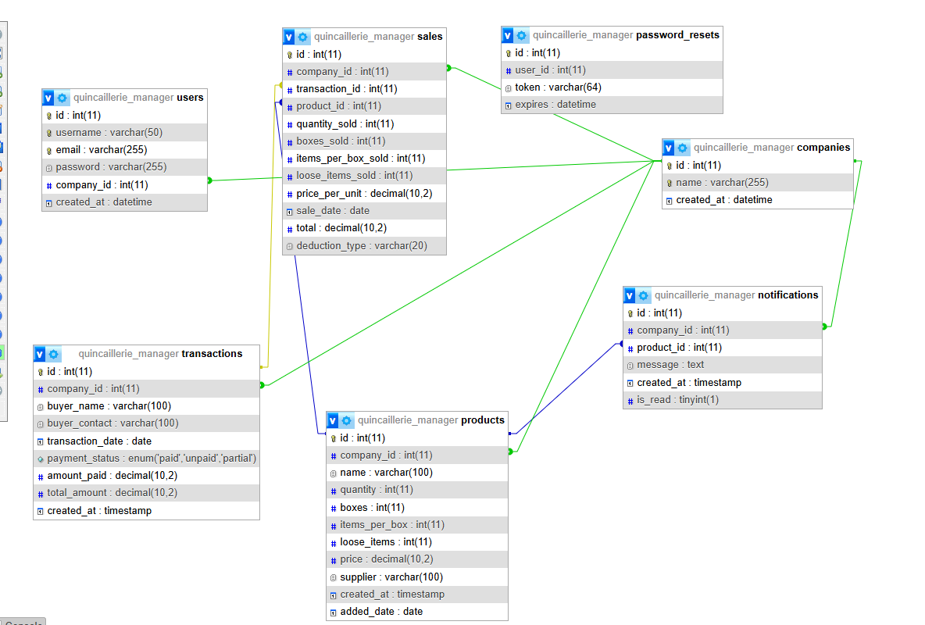
- User Actions: Registration, login/logout, role-based access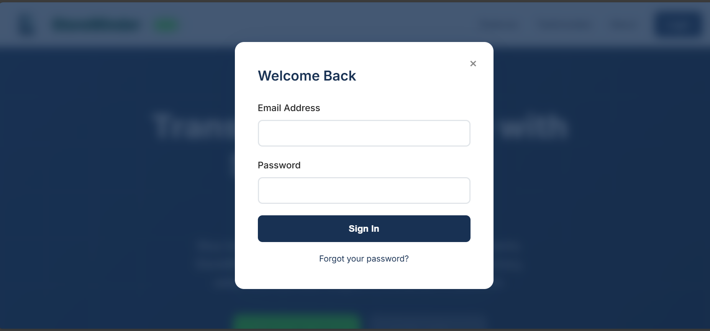
- User SignUp
